eLearning Application in Risk Management

Hossein Akhlaghpour: Chief Technology Officer, ObjectJ Inc.
Saeed Akhlaghpour: MBA Dept, Sharif University of Technology
Mahmoud Mortazavi: eLearning Specialist, ObjectJ Inc.

Abstract:

In this article we present the following topics:
- Introduce the concept of Financial and Real Risk Management (including Stock and Real Options).
- The importance of risk mitigation in today’s volatile market
- Essential tools to help us assess, prevent and manage risks.
- How eLearning technology can be used to provide such a tools for industrial and academic projects

Introduction

Risk Management is one of the most important topics in today’s MBA programs. Managers have full responsibility dealing with all risks facing the organization, including both speculative and pure risks. “Risk Management is a scientific approach to the problem of dealing with the pure risks faced by individuals and businesses” (Lam & Kawamoto, 1997)

On the other hand in recent years we are witnessing the birth of a new technology (infrastructure and tools) for learning called electronic learning or eLearning. eLearning has a specific characteristic that makes it different from other distance learning including the computer based learning and that is the use of Internet as a mean of transferring content to learners or communicating between different parties involved in the learning process. What Internet provides is the following characteristics:

- Having access to the largest source of information & largest community in the world and that is Internet content and its users
- Internet provides two-way communication protocol and not only content is accessible to every Internet user but their feedback and interactions are accessible to us. That makes it much more valuable than a media such as book, Newspaper or TV.
- It includes one of the best security protocols of accessing information. Meaning you can access who can access what part of information and be sure that unauthorized access is prohibited or at least monitored.

In the last couple of days different industries has been using eLearning to reduce the cost of job training. eLearning is being used as a tool to bring employees up to speed by updating their knowledge and skills throughout the company. eLearning uses much less time and cost than conventional learning methods to perform such a task.
From this viewpoint eLearning is not only a method of learning; rather it is a set of standard and technology to communicate with employee easily and frequently.
In this article we propose to use such a tool to not only train the concept of Risk Management to all employees, but also gather the raw data necessary to perform such an analysis and finally measure the success of applying risk management throughout the company.

What is Risk?

Before we jump into the topic of risk management let us first define the concept of risk in business management.
Risk is anything that may affect the ability of organization to achieve its objectives
Risks may cover the following forms:
- Hazard - Bad things are happening
- Uncertainty – Things are not occurring as expected
- Opportunity – Good things are not happening

By this definition a risk can be even a possibility of missing an opportunity. In Risk Management Science, three types of risk have been defined:

- Inherent Risk:
Absence of any internal controls
- Residual Risk:
The risk remaining after the application of controls
- Acceptable Risk:
Business can tolerate that risk

The goal of risk assessment is to reduce risks to an acceptable (or tolerable) level. Of course a zero risk level is not attainable. For this reason, it is very important in risk management to define the acceptable risk. To reduce the level of an inherent risk to an acceptable one you need to have mechanisms to control it. Any risk that is under the control is called Residual Risk (even if it may be above the acceptable level).

Why Risk Management?

At first investing time & money on such a subject may be a luxury work. After all we can always deal with risk when it happens. However in today’s business market where a fell in Dow Jones Index can be felt all the way in china, even small businesses are affected by global market. Business models have become more complex and are sensitive to many changes. Therefore applying Risk Management has turned from a luxury tool to a necessity, especially in large companies.

As an example we can look at GM. GM is the largest car manufacturer in the world. Just in 2003 it produced more than 30 new vehicles. GM subsidiaries are all around the world from US to Asia and Japan. Therefore even currency exchange rate may affect GM profit. Risk Management plays a key role in shaping the strategic decisions in GM. The following is the list of main risks that are being handled in GM Risk Management process:

- Legal risk: As the largest car manufacturer in the world GM is exposed to many legal disputes. An example is the recent concern on the use of encapsulated asbestos in its car brakes that may increase the risk of asbestos-related disease. A growing number of auto mechanics were filing suit seeking recovery based on their alleged exposure to the small amount of asbestos used in brake components. Such law suits may be very costly for GM, not considering it may be a ground for recalling its products.
- Currency risk: GM faced a range of foreign currency exposures. There was uncertainty about future earnings or asset and liability values as a result of operating cash flows and various financial instruments that were denominated in foreign currencies.
- Interest rate risk: GM was exposed to changes in interest rates due to its financing, investing, and cash management activities. GM was vulnerable to interest rate risk associated with long-term debt and contracts to provide commercial and retail financing, retained mortgage servicing rights, and retained assets related to mortgage securitization.
- Commodity price risk GM was exposed to changes in prices of commodities like various non-ferrous metals used in the manufacturing of automotive components. GM entered into commodity forward and option contracts to offset such exposure.
- Equity price risk: GM was exposed to changes in prices of various available-for-sale equity securities in which it invested.

The job of Risk Management is not only to identify risk, but also to quantize it. It should help the manager to answer the following questions regarding the risks that expose the company:

  - How severe is the consequence?
  - How likely is the occurrence?
  - Is the risk exposure acceptable?
  - How soon must the risk be dealt with?
  - What is causing the risk?
  - Are there similarities between risks?
  - Are there dependency relationships?
  - What are the risk drivers?

Real Options

There is even a science to quantify the risk and take it into account in the company valuation. It is called Real Options. Real Options is the analogues of the Financial Options that has been used in Stock Market for long time. Just as a financial option gives its owner the right — but not the obligation — to purchase or sell a security at a given price, A company that has a real option has the right — but not the obligation — to make a potentially value-accretive investment. Investment examples are:
  - new plants
  - line extensions
  - joint ventures
  - Licensing agreements.

Any investment introduces new opportunities as well as new risks. Calculating this (opportunity) risk value and assigning a number is the main subject of this science. Real Option determines the value of a project or company based on a mathematical theory called the binomial model. The binomial option-pricing model describes price movements over time, where the asset value can move to one of two possible prices with associated probabilities.

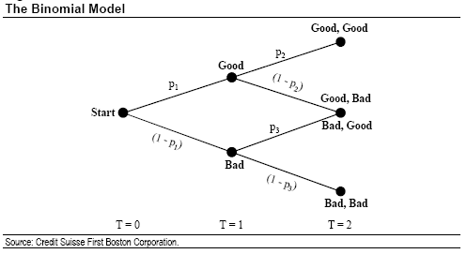

This is a modern pricing model that incorporates chance & probability versus the conventional one called Discounted Cash Flow (DCF) or Net Present Value (NPV) that determines the value of a company only in terms of the future cash flow.

NPV comes up short when deals with:

- Contingency. This is a situation when future investments are contingent on the success of today’s investment.
- Volatility. Investments with greater uncertainty
- Flexibility. Flexibility is the ability to defer, abandon, expand, or contract an investment.

As you can see with the present volatility of the market, Real Option becomes an important role not only to assess the risk but also to exchange the risk (opportunity) with real values Just as in Finance where you can limit your risk by purchasing financial options (This is the main subject of special field in finance called Credit Derivatives), a company may limit its risk by investing in certain projects or participating in certain joint ventures. To calculate such an investment value people use Black-Scholes model. Black-Scholes formula is being used in stock market to calculate the value of Call and Put options. The same formula can also be used for investment (project) valuation.
Call Price  Put Price  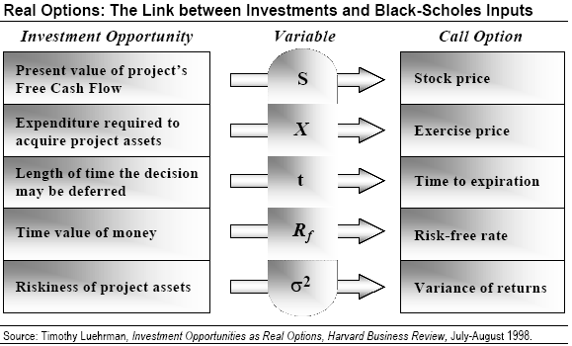 | 

As we can see Real Option is a framework to quantize risk assessments not only for enterprises but also for specific project. As companies become more multinational and we see more and more acquisition to save operational cost, the need to have the right science and tools for assessing risk becomes crucial for the life of future companies. As a result we will see more demand for experts in the field of risk management and real options and that translates to higher demand for learning these subjects.

eLearning

There is not a definite list of what constitutes eLearning. Some consider eLearning as any learning material that is presented in Internet. With this definition a simple web site may be called eLearning and some went far enough that include large applications such as eCommerce as one of the eLearning components:
However we can list the following as the essential parts of any eLearning package:

Assessment
Tool
Authoring
Tool
Virtual
Classroom
Learning Management System
Content
Management System

- Learning Management System (LMS): Presents the learning materials to students while maintaining the full security of such an access (authenticity of material and authorization of students). LMS is also responsible to track student progress and create all sort of reports related to his education
- Authoring Tool: Learning materials has to be in specific formats to be presentable in Internet and at the same time should follow certain eLearning standards (such as SCORM) to be able to communicate with LMS (pluggable to LMS). Author of eLearning materials needs a tool designed to develop contents with such a standards. Such a tool is called Authoring tool
- Content Management System (CMS): A tool to manage the content provided for eLearning. By management we mean categorizing that content such that one can easily find the relevant content by navigating through its classification or by searching through the content using a search engine. (Recent eLearning tools combine LMS with CMS functionality and call it CLMS)
- Assessment Tool: LMS can be used to track student progress in taking the courses or performing their homework, however without real exams one cannot track what a student has really grasped. Performing an online exam similar to the conventional exam requires specific tool that is designed for such a purpose and that is called Assessment Tool. Instructors use Assessment Tool to design the exam materials (variety of questions, such as multiple answered quizzes, etc.) and then define a specific exam (including it’s duration, number of questions, type of questions, passing score, validation period, etc.). Once the exam is ready, students can take the exam and monitor their scores.
- Virtual Classroom: Often in eLearning you require direct & live interaction between students and their instructor, meaning we need a Virtual Classroom that resembles the real classroom. In Virtual Classroom an instructor can present the materials to his students in real time and students can participate in the class by asking questions through the use of voice/text chat or share their feedbacks via sharing specific applications such as a whiteboard. Virtual Classroom can also be used for students to collaborate with each other or even held a brainstorm session.


Progress
Report
Content
Author
Student
Live
Content
Instructor
Progress
Report

Even though eLearning with all of these tools cannot bring the full experience of the conventional learning, it removes the physical and time barriers on learning and provides learning opportunities that we may never have in the conventional learning.

eLearning & Risk Management Process

eLearning plays dual role in risk management. On one hand it is a tool that you can use to teach risk management and the relevant techniques to employee and on the other hand it can be used as a tool to implement risk management.
The former is a trivial use of eLearning as it can be used to teach any other content. Of course risk management subject is a good candidate for eLearning content due to its complexity and volatility of its content.
On the later case, eLearning provides an environment that you can
- identify risk via eLearning,
- use it to better analyze the risk,
- track the risk
- and finally add what you learned from the risk to eLearning content repository.

eLearning plays a communication media to facilitate risk management.

The following diagram shows the position of eLearning on the risk management process:

Identify risks
Resolve risks
Analyze risks
Plan for risks
Track risks
Learn about risks
Risk
Knowledge
Base

We go over each step and identify how eLearning can help us to achieve those functionalities:
eLearning in a company is not only a tool to train employees, but also is a tool to assess their competencies. This assessment can be for what you teach them (like taking exam) or any other aspects of their knowledge. In a way it can be used to get all kinds of feedback from employee in a cost effective and swift manner.
Therefore once the employee get familiar with using the assessment tool to take for example an online exam nothing prevent us to use the same tool and have them fill up a survey, especially if they see an incentive for it. Taking the right surveys is one of the best ways to identify hidden risks or to assess a risk throughout the company.

Once the risk is identified you need to analyze it, find out how serious the risk is and how one may control such a risk. One place to start such an analysis is to look at the previous experience of managing similar risk on other companies or managing other risk on the same company. To access and manage such information you need a content management system and that is part of any eLearning system. You can search, view and categorize risks and its outcomes in the database of an eLearning CMS tool.
Once you analyze the risk and come up with a plan to control it, you need to measure the success of your plan. Meaning you need to know how much people takes those measures seriously and how effective is your plan. Therefore you need to receive employee feedback on the plan implementation. This is again a place for assessment tool. Sometimes you may want to hold a brainstorm session with a short notice and this is when you can take advantage of the eLearning Virtual Class room. VC let you held a live online meeting no matter where different parties are. It plays the online conferencing and collaboration tool for the company.

Finally once the risk is controlled and you find the resolution. You can feed the result into the eLearning CMS such that it can be used in future risk managements.
Of course the design of CMS in terms of
- how it receive the data,
- how user friendly would be the interface
- how it categorizes the data
- and how searchable would be the content
is essential of its efficiency in its future use of risk management.
In general even though eLearning has all of the essential parts of providing the right infrastructure and tool for risk management, a customized implementation of eLearning is required to make it practical for companies to consider it seriously for their risk management.
Conclusion

Risk Management is an essential in today’s business valuation
Risk Management Needs what eLearning offers
- Right infrastructure to receive the input from different sources as fast as possible
- Assessment tool
- Collaboration for brainstorm any time
- Training on new subjects to
provide fast response to market change
- Notify all affected stakeholders:

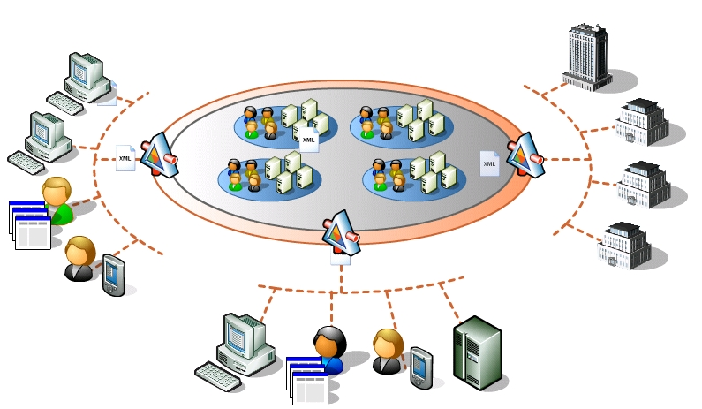

Reference:

- Get Real: http://www.capatcolumbia.com/Articles/FoFinance/Fof10.pdf

- Risk management at General Motors: http://www.vedpuriswar.org/articles/GCEO/RM%20at%20GM.PDF

- Real Options and the Theory of the Firm : http://www.realoptions.org/papers2004/RoemerROC2004.pdf

- http://www.processimpact.com/articles/risk_mgmt.html

- http://www.columbia.edu/~jm2217/#Risk

- http://www.baz.com/kjordan/swse625/intro.html

- Hall, Elaine M. Managing Risk: Methods for Software Systems Development. Reading, Mass.: Addison-Wesley, 1998

